

The OSSCA Quarterly

March

2019

ATTRACTIONS

Message from the President

John Johnson

From the Executive Director of OSSCA

Gary Avedikian

From the President of USC

Jeff Farnsworth

From College Coaches

Coach Brian Maisonneuve, Ohio State University Men’s Coach

From Ohio High School Coaches

Coach Bryan Daniel – Indian Hill; VP for OSSCA Education

Coach Zorro – Sword High School, Goalkeepers, Let’s not forget them.

From the Director of Referees for the OHSAA

Don Muenz, OHSAA Soccer DoD

From the Fitness and Nutrition Specialist

USADA

From the Sports Psychologist

Dr. Steve Graef, PhD

Counseling/Sport/Performance Psychologist for Ohio State University Athletics

From A Member: Questions of the Month

Dino McIntyre, Walsh Jesuit H.S.

Suggested Goalkeeper Training Ideas

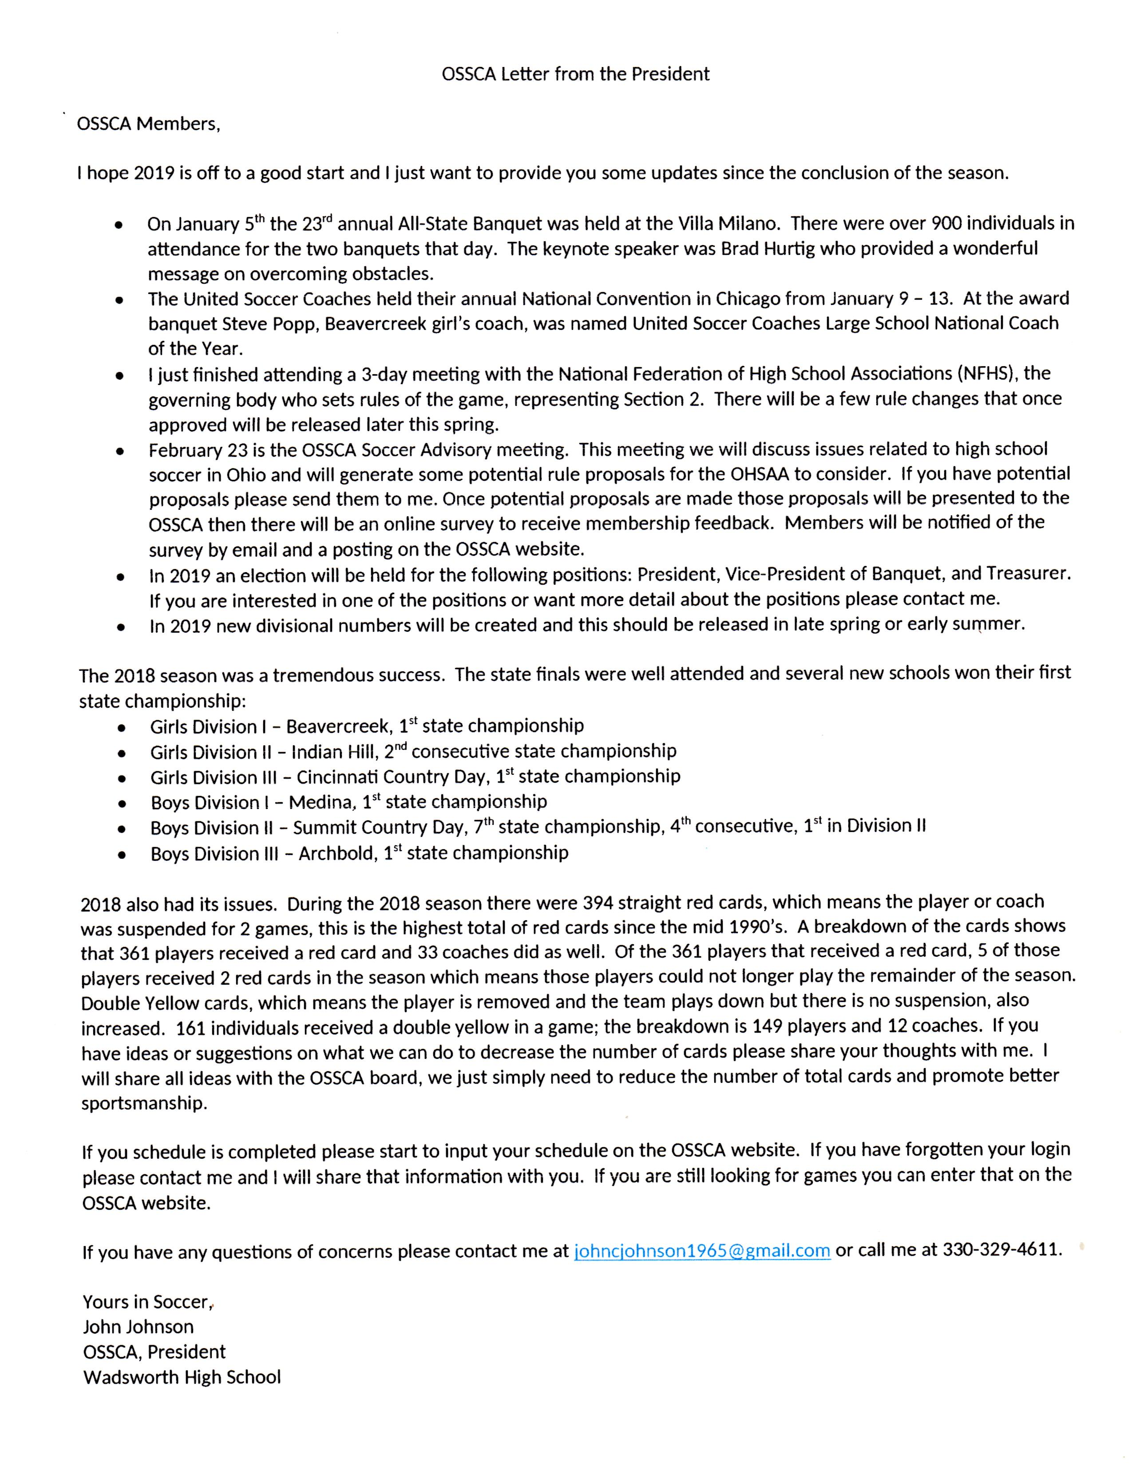

From the Executive Director of OSSCA

Gary Avedikian

As coaches we need to be particularly concerned with the minds of our injured players. Too often, we are mostly concerned with getting them treated quickly and safely for the most correct reasons. Many of us can fail to realize the impact of the injury on the person’s mental wellbeing.

Here’s an example of what can go wrong: It is September. A player is starting in their first college game as a sophomore on a team where sophomores don’t normally start games. In the first half, the player sustains a serious knee injury. The trainer (a student trainer) ices it but gives no real instructions as to how to proceed with post-game follow up or dealing with the school’s medical staff. (Don’t assume this couldn’t happen today)

The player returns home rather than to the college. The father, thinks that they should get the best doctors involved. The family doctor is friends with the Red Sox surgeon. Red Sox surgeon asks critical question: “will the player be a professional?” Answer: No. Surgeon: Let’s operate in December.

The college trainers help get the swelling down, somewhat, but then they tape the knee and send the player out to practice again. Player can’t perform. Sits that fall. No one pushes for more immediate surgery or continuing to maintain the strength in the knee. Player and family have no experience with whole situation.

After surgery in December, player is given some rehab but there is no one assigned to support the player either physically or psychologically. Rehab goes, virtually, not at all.

Player tries again to play the next fall but leg is weak and the player can’t regain former form.

Scratch one career in soccer and track, what the player was living for.

When our players are injured, we need to assume that no one but us can help the player with the mental trauma associated with their injury. Many times, the players aren’t reassured by their parents in these situations. Players know their parents are just saying things they hope are true.

Players are immediately frightened as to just how serious are they hurt. Will they play again? Will they lose their position in the team? Will the other players care? Will my coach forget about me and move on to another player(s)?

This is where as their leader, mentor, and supporter we need to be ready and willing to speak to them, visit them, help them with the transition back to the team through counseling of the other players and the returning player.

Be really aware of your player’s mental trauma as well as their physical trauma.

Additional Information that Has Been Requested:

2019 OHSAA Soccer Calendar

**2019 Soccer Calendar**

|  |  |
| --- | --- |
| Aug. 1 | First Day of Coaching |
| Aug. 2 | First Day H.S. Preview Permitted |
| Aug. 16 | Season Begins |
| Oct. 6 | OHSAA Tournament Draw |
| Oct. 7 | Non-Interscholastic Date |
| Oct. 14-19 | Sectional Tournament |
| Oct. 21-26 | District Tournament |
| Oct. 29-Nov. 2 | Regional Tournament |
| Nov. 5 | Girls Soccer State Semifinals |
| Nov. 6 | Boys Soccer State Semifinals |
| Nov. 8 | Girls Soccer State Finals |
| Nov. 9 | Boys Soccer State Finals |

Coaches' No Contact Period begins on the first day after the last interscholastic contest and ends 28 days later.

**From the President of USC**

**Jeff Farnsworth**

United Soccer Coaches President

I would like to begin by stating what a deep appreciation I have for high school soccer and what it represents. I have been involved with soccer as a coach or administrator at almost every level. I started as a high school coach in Spencerport NY just outside of Rochester. My heart has never left. You high school coaches are probably the hardest working and most underappreciated of any level of coaching. You teach all day, plan lessons, grade papers before planning your practices. Then you go coach, fundraise, deal with injuries, parents, media and then spend just a little time with your own families. Through my years in working with this association, when something needed to get done, and done well, we could always rely on the high school coaches.

This is my 34th year working with the United Soccer Coaches Association. Through the years I have had the pleasure and honor of working with some of the high school greats and legends of this association. These men became both good friends and mentors to me. Past NSCAA Presidents Bill Holleman from Georgia, Millar Bugliari from NJ, Steve Malone from Maryland, Gary Avedikian from Ohio, Rob Robinson from PA, Jay Engeln from Colorado, and my HS soccer coach Ron Broadbent from NY. These men worked tirelessly and did so much for HS soccer and this association. I am humbled to follow in their footsteps. They all left such a positive mark on the United Soccer Coaches and on soccer!!!

As I begin my term as president, my vision for high school soccer over the next few years is to establish United Soccer Coaches affiliated state associations in every state developing a high school structure across the USA! A unified high school voice in every state as well as a across the country. What a powerful organized voice high school soccer could become uniting all these state associations. New State association modeled after what you have done in Ohio would have enhanced educational opportunities, increased awards for both coaches and players, contacts with other state associations, a greater voice with the HS Federation and marketing opportunities for all. I envision high school state association leadership meetings at our convention every year to discuss common issues, strategies, concerns, marketing, awards, rules, and coaching education. So much potential for growth, visibility and marketing!!!

The second issue that I will continue to advocate for is giving all kids the opportunity to play High School soccer. What a shame that some high school kids must choose between playing club and high school soccer. Both my kids played Youth and High School soccer for excellent coaches, both received college scholarships. They value their HS experience at or above their youth, ODP, or college. They had fun, built lasting relationships with teammates, with coaches, and held leadership positions on their HS teams! My daughter Kara is the head women’s soccer coach at Columbia International University in South Carolina! She played 4 years of high school soccer!! High school soccer is still so very important to her!

We don’t have a say over what US Soccer does, that is totally under their control. The United Soccer Coaches membership includes coaches from both Youth and HS and we need to support all our members. But I strongly believe kids should be allowed to play high school soccer! Allowed to play with their childhood friends, family and for their community! To enjoy being leaders on their teams, to play games that their community and the media care about! I was at the MAC Hermann trophy presentation in early January in St Louis representing the United Soccer Coaches. I sat next to US Soccer’s Secretary General Dan Flynn. In Dan’s speech to the crowd, he spoke about the value of college soccer. Dan said that college soccer helps develop quality players because they are playing games that matter!! Not friendlies, but every game they play is important. This develops quality players!! The same concept is true of high school soccer. Every game you coach, every game your kids play matters. As Dan said THIS DEVELOPS QUALITY PLAYERS! You coaches create the environment that improve players because you play games that matter. You teach, you inspire!!!

We certainly cannot control decisions of other soccer organizations. But we can become a more unified high school voice. We can continue to educate people to the strengths and benefits of playing high school. We can continue to promote coaching education to improve the level of play in high school soccer and to continue to organize and elevate high school soccer across the country. You high school coaches are some of the most dedicate, organized and hardest working soccer coaches I have had the pleasure to work with. You do much for soccer in this country and to impact your player’s lives!!! Your schools, communities and players are indebted to you for all you do! My hope is that we can continue to move high school soccer forward to new heights in this country, where all kids can get the opportunity to play for their high school.

From College Coaches

Coach Brian Maisonneuve, Ohio State University Men’s Coach

1/30/2019 Drill Print - Session Planner 4.0

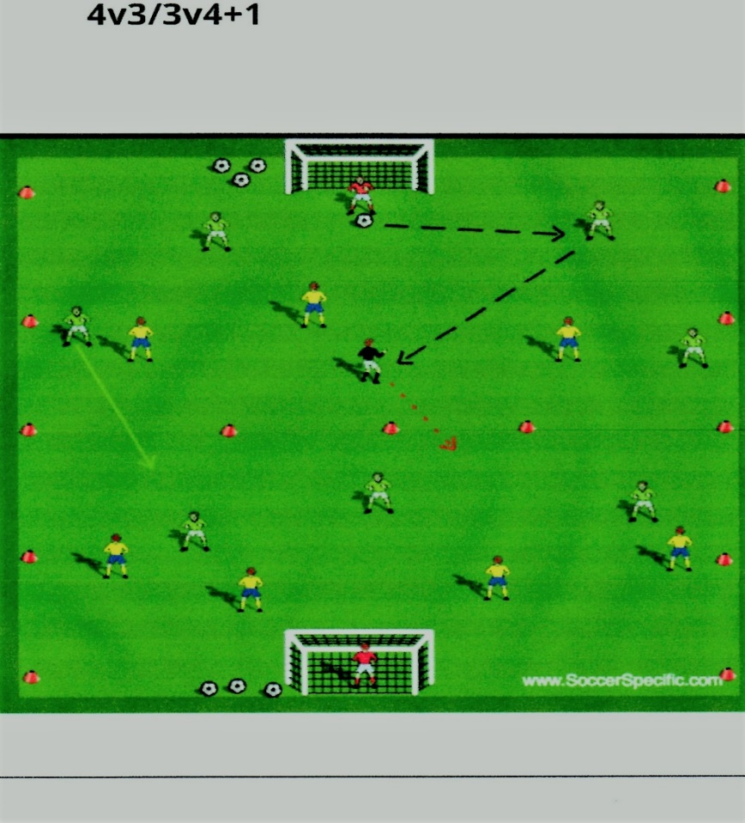

**Setup**

60x50 (with midline at 30 yards). GK and Green Back 4 in defending half, 3 Green Attackers in attacking half. GK and Yellow Back 4 in defending half, 3 Yellow

Attackers in attacking half. Neutral in Black. Balls divided up in both goals.

**Instructions**

Green are trying to build out of back using neutral player. Once ball enters attacking half-one player (usually wide back) can join to make it 4v4 +1. Other players

must stay in assigned half. Neutral player can cross over into other half.

Yellow wins the ball that team now tries to build (4v3+1) and attack Green goal.

Goal is scored-scoring team restarts with a ball from their GK.

Ball goes out of bounds-restarts with GK from team in possession.

**Coaching Points**

CP's and Variations of Play:

Building the ball out of the back using your positional 6 as the pivot (can limit touches in back half)- CP: angles/ spacing, looking to play forward, awareness of where

ball needs to go before you receive the ball.

Can mandate the ball needs to be passed into attacking half- working on entry balls forward-CP: timing/spacing of attacking players.

As the ball enters the attacking half both the neutral and outside back can join the attack when appropriate-CP: timing of runs from outside backs.

Defenders in defensive half need to sort out shape as they will be 3v3 for the time of the attack-CP: defensive shape as you attack.

Once ball is in attacking half you will be playing even or numbers up. Working on combination play, recognizing #'s up situations-CP: decision making (when to attack

or possess), finishing.

Can limit touches in attack half or can mandate a 1 touch lay o_ from the entry ball-CP:increase player movement and thought process.

From Ohio High School Coaches

Bryan Daniel, Indian Hill, VP for Education

Coach Zorro – Sword High School - Favorite practice

Many times, the forgotten person on our team, due to a lack of knowledgeable assistants, is the goalkeeper. Many of us have limited knowledge because we are 10 times more likely to have been a field player ourselves. Please find at the end of the Quarterly an extensive set of suggested training activities for your goalkeepers.

From the Director of Referees for the OHSAA

Don Muenz

**But, Ref, My Player Never Touched the Ball………………**

There seems to be a bit of confusion, both on the part of referees and coaches/players, concerning the necessity of touching the ball to complete the foul of offside.

NF 11.1.4 states: “Player is in offside position and penalized if, at the time the ball touches or is played by a teammate, the player in an offside position becomes involved in active play by: (a) interfering with play or an opponent, or (b) seeking to gain an advantage by being in that position.”

It is understood that if an offside position (OSP) player touches the ball, that completes the foul of offside, i.e., interfering with play, NF 11.1.4(a).

An OSP player completes the foul of offside by touching the ball, on a teammate’s shot rebounding from a goalpost or crossbar, by receiving a shot saved by a goalkeeper or other defender or by receiving a ball deflected (i.e., NOT deliberately played) off of a defender. This involvement in the active play is termed gaining an advantage by being in an offside position.

What about this sketchy concept that an OSP player can be guilty of offside without so much as touching the ball? That cannot be correct, can it? After all, does not NF 11.1.3 state that “It is not an offense in itself to be in an offside position”?

Let’s look at this. A player in an OSP is not permitted to touch the ball. We just went through that. It is also true that some actions or inactions by an OSP player can be so unfair as to be considered involvement in the active play *without the ball’s being touched.*

Let’s look at some examples.

A1 has been edging toward the halfway line in his own defensive half of the field and Team B has pushed everyone forward but the goalkeeper in an attempt to equalize. Only goalkeeper B1 remains in Team B’s defensive half. Unable to contain himself, A1 edges one foot into his attacking half. A5 sends the ball over the top and it comes down halfway between A1 and B1. The lead AR has popped her flag, as these opponents race toward each other at madcap speed. The referee is unimpressed, figuring that B1 will easily reach the ball first, forestalling that pesky whistle. Two seconds later, A1 and B1 lay scattered on the turf in differing stages of consciousness and disarray.

The coaches are rightfully irate with the referee.

Why didn’t the referee honor his AR’s flag and prevent this wholly unnecessary train wreck? Could the referee have been under the mistaken impression that until A1 touched the ball there could be no offside?

Once more, let’s look at NF 11.1.4(a), “Player is offside and penalized if, at the time the ball touches or is played by a teammate, the player in an offside position becomes involved in active play by (a) *interfering with* … *an opponent* … .”

Now, it fits together. If an OSP player has no right to play the ball, then she has no right to (1) trick or deceive an opponent while in OSP; (2) get in the opponent’s way to prevent her seeing or playing for the ball; (3) put the opponent, who has every right to play the ball, at risk of injury, etc.

The Offside Rule fits nicely with the referee team’s duty to promote safe play and prevent, where possible, and then punish, if unpreventable, unsafe play.

Let’s look at other examples.

A1 is in OSP. There are no other Team A players in their attacking half. A through-ball is played down the wing by A8 and B7 attempts to chase down A1. A1 has drawn B7 to herself and has become involved in the active play, without touching the ball, by interfering with an opponent. A1 illegally challenged B7 for the ball.

A1 is in OSP. A2 is in onside position. The ball is played by A9 toward A1, who runs to it. B1 runs toward A1’s position to defend A1. At the last moment, A1 raises her leg to allow the ball to run past her so that A2 collects it, leaving B1 unable to defend A2. Offside for interfering with an opponent, despite A1’s not having touched the ball. Here, A1 clearly attempted to play a ball which was close and this action impacted B1’s ability to defend.

A1 is in an OSP at the time that A2 shoots on goal. The shot deflects off of the crossbar (or goalpost or Team B defender or is deliberately saved by any Team B player) and comes toward A1. A1 realizes that if he touches the ball, he will be given offside for gaining an advantage while being in an OSP. A1 attempts to shield the ball from an opponent until A2 can come forward and gain possession. This is offside, for gaining an advantage while being in an OSP, despite A1’s not having touched the ball. A1 interfered with an opponent. A1 had no right to play the ball, while any Team B defender had every right to play the ball.

A1 is in an OSP within her attacking goal area. She does not move with goalkeeper B1, but stands in front of her just as A2 takes a shot. In the opinion of the AR, B1 cannot see the ball and it enters the goal untouched. The AR believes that A1 prevented B1 from seeing the ball and from having the opportunity to play for it. The AR pops her flag. The referee backs over to her, hears what she has to say and gives an indirect free kick to Team B, for interfering with an opponent.

A last word about the spot of the foul. It used to be that the indirect free kick for offside was taken from the spot where the OSP player was when a teammate touched the ball. **Not so anymore.** Now, the indirect is taken from the spot where the foul is completed, i.e., where the OSP player became involved in the active play by interfering with play or with an opponent or gained the advantage by being in an OSP. The spot of the foul is subject to the special conditions set forth in NF 13.1.3.

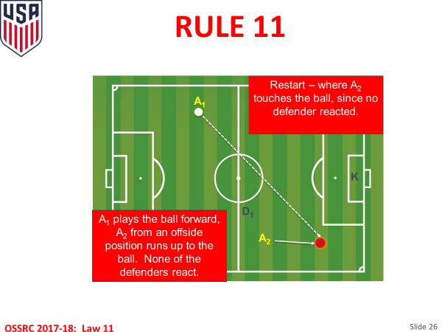

In this situation, A2 is in OSP and A1 plays the ball over the top. The indirect is taken from the spot of A2’s interfering with play, i.e., at the “X.” In this situation, we state that neither D1 nor the goalkeeper, K, were interfered with.

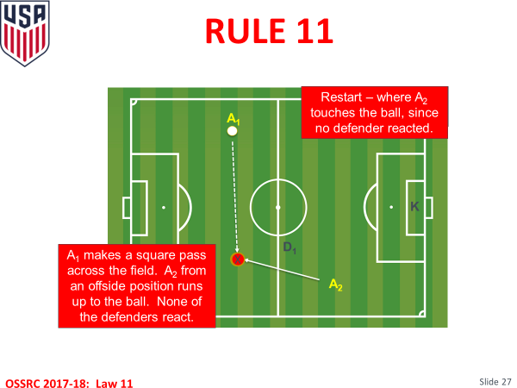

In this situation, A2 is in OSP. A1 plays a square pass across their own defensive half of the field. A2 runs back into their defensive half and touches the ball. The spot of the indirect for Team D is where A2 interferes with play by touching the ball, i.e., at the “X,” here, in their own defensive half. Once more, we assume that no defender is interfered with.

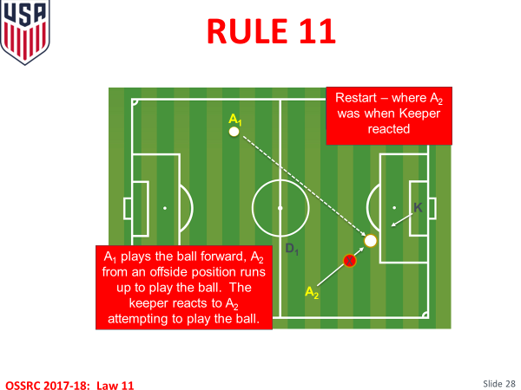

In this final situation, A2 is in OSP, when A1 plays a through ball. D1 does not react, but goalkeeper K does. The spot of the indirect is where the oncoming, OSP A2 caused goalkeeper K to move to play the ball. This is where A2 interfered with an opponent.

Please feel free to send me video clips and questions this coming year and any from last year about which you may have a question. I’ll be please to address them and we can learn together.

Best wishes for the New Year and keep bringing out the best character in your players. It’s your legacy to the game.

don

**Eight Rules Changes Approved in High School Soccer**

**February 26, 2019**

**NATIONAL FEDERATION OF STATE**

**HIGH SCHOOL ASSOCIATIONS**



**NEWS RELEASE**

**EIGHT RULES CHANGES APPROVED IN HIGH SCHOOL SOCCER**

**FOR IMMEDIATE RELEASE**                                                                                                    Contact: Theresia Wynns

INDIANAPOLIS, IN (February 26, 2019) — Rules related to improperly equipped players and procedures for dropping the ball are among eight rules changes in high school soccer for the 2019-20 season.

The rules changes were recommended by the National Federation of State High School Associations (NFHS) Soccer Rules Committee at its January 28-30 meeting and subsequently approved by the NFHS Board of Directors.

“While there are not any substantial revisions to the rules this year, I believe coaches and players will be pleased with the changes we have made,” said Theresia Wynns, NFHS director of sports and officials education.

Rule 4-3 will now specify that an improperly equipped player will not require teams to play shorthanded. The improperly equipped player will be asked to leave the field when the ball is not in play if the issue cannot be resolved immediately on the field, and the player may be replaced.

Once the offending player is properly equipped, he or she can report to an official. If the player was not replaced, he or she may re-enter the game at a dead ball. Infringement of the rule will not cause the game to be stopped unless a referee determines the situation is dangerous.

The rule was changed because the penalty for an improperly equipped player was more severe than the punishment for illegal equipment. The rule change ensures both infractions are handled equally.

With regard to the dropping of the ball in Rule 9-2-3, any number of players, including the goalkeeper, may now contest a dropped ball, and the referee cannot decide who may contest a dropped ball or determine its outcome.

Two new articles were added to Rule 9-2 to further clarify a dropped ball. Article 5 states the ball should be dropped again if it touches a player before hitting the ground or if it leaves the field after hitting the ground without touching a player. Article 6 states that if a dropped ball enters the goal without touching at least two players, the play must be restarted with a goal kick if it entered the opponent’s goal or a corner kick if it entered the team’s own goal.

Rule 9-2-1c was amended to remove the provision that if a team is in clear possession of the ball, the game will not be restarted with a drop ball. The rule now states the only time a game will not be restarted with a drop ball following temporary suspension of a player, injury or unusual circumstances is when the goalkeeper is in possession of the ball.

A change to Rule 9-3 eliminates free kick opportunities by replacing an indirect free kick with a drop ball if the ball was not in the goal area and in possession of the goalkeeper during cases of temporary suspension due to injury or an unusual situation.

An addition was made in Rule 3-4-3 to state that the clock should be stopped when the leading team makes a substitution within the last five minutes of the second period. The new rule is meant to prevent coaches in the lead from wasting time and running the clock when no plays are being made.

The final change was to Rule 5-3-1d that now allows officials to call out “play on” with an underswing of one or both arms.

“Our game is in pretty good shape,” Wynns said. “There will be a few changes this particular year, but the rules revisions that have been made will not change the game for the most part.”

A complete list of soccer rules and changes can be found on the NFHS website, [www.nfhs.org](http://www.nfhs.org/) under “Activities and Sports”.

According to the 2017-18 NFHS High School Athletics Participation Survey, soccer is the fifth-most popular sport for boys with 456,362 participants in 12,393 schools across the country. Soccer is the fourth-most popular sport for girls with 390,482 participants in 12,007 schools.

*This press release was written by Kirsten Adair, an intern at the NFHS Publications/Communications Department.*

**###**

**About the National Federation of State High School Associations (NFHS)**

The NFHS, based in Indianapolis, Indiana, is the national leadership organization for high school sports and performing arts activities. Since 1920, the NFHS has led the development of education-based interscholastic sports and performing arts activities that help students succeed in their lives. The NFHS sets direction for the future by building awareness and support, improving the participation experience, establishing consistent standards and rules for competition, and helping those who oversee high school sports and activities. The NFHS writes playing rules for 17 sports for boys and girls at the high school level. Through its 50 member state associations and the District of Columbia, the NFHS reaches more than 19,000 high schools and 11 million participants in high school activity programs, including more than 7.9 million in high school sports. As the recognized national authority on interscholastic activity programs, the NFHS conducts national meetings; sanctions interstate events; offers online publications and services for high school coaches and officials; sponsors professional organizations for high school coaches, officials, speech and debate coaches, and music adjudicators; serves as the national source for interscholastic coach training; and serves as a national information resource of interscholastic athletics and activities. For more information, visit the NFHS website at [www.nfhs.org](http://www.nfhs.org/).

**MEDIA CONTACTS:**Bruce Howard, 317-972-6900

                                                      Director of Publications and Communications

                                                      National Federation of State High School Associations

[bhoward@nfhs.org](mailto:bhoward@nfhs.org)

                                                      Chris Boone, 317-972-6900

                                                      Assistant Director of Publications and Communications

                                                      National Federation of State High School Associations

[cboone@nfhs.org](mailto:cboone@nfhs.org)

From the Fitness and Nutrition Specialist

USADA

Nutrition Guide by TrueSport – Available on line as a PDF

[www.TrueSport.org](http://www.TrueSport.org)

Contents:

Carbohydrates – The Master Fuel

Protein’s Role as a Team Player

Building Body Mass

Fat as Fuel

Vitamins and Minerals

Supplements and Your Health

Fluids and Hydration

Bottom Line

**Resources:**

**www.acsm.org** American College of Sports Medicine

**www.eatright.org** Academy of Nutrition and Dietetics

**www.Supplement411.org** USADA’s Supplement 411

**www.fda.gov/food** U.S. Food and Drug Administration

**www.fda.gov/safety/recalls** FDA Recalls, Market Withdrawals, & Safety Alerts

**www.usda.gov/cnpp** Center for Nutrition Policy and Promotion

**www.health.gov/dietaryguidelines/2015** Dietary Guidelines for Americans, 2015

**www.nutrition.gov** National Agricultural Library, U.S. Department of Agriculture

**www.health.gov/nhic** National Health Information Center - U.S. Department of Health and Human Services

**www.sportsrd.org** Collegiate and Professional Sports Dietitians Association

**www.scandpg.org** Sports, Cardiovascular, and Wellness Nutrition, a dietetic practice group of the Academy of Nutrition and Dietetics

Sports, Cardiovascular, and Wellness Nutrition Dietetic Practice Group. Sports Nutrition: A Handbook for Professionals. 6th ed., Chicago: Academy of Nutrition and Dietetics. 6th Edition. 2017.

**Acknowledgement:**

*A very special thanks to Mackenzie White, M.S., R.D., CSSD, LD, CSCS; Jacqueline R. Berning, Ph.D., R.D., CSSD; and Alicia Kendig, M.S., R.D., CSSD for contributing the content for this publication.*

From the Sports Psychologist for the OHSAA

Dr. Steve Graef, PhD

Counseling/Sport/Performance Psychologist for Ohio State University Athletics

Owner of Mindurance

[Drsteve@mindurance.org](mailto:Drsteve@mindurance.org)

[www.mindurance.org](http://www.mindurance.org)

One evening I decided to drive to Indianapolis because I was seeing Les Miserables for the matinee show at Murat Theatre.  However, given that it was also St Pattys, and that I am a huge fan of St. Patty’s Day I decided to take in just a little bit of the revelry.  One stop took me to the Broad Ripple BrewPub where I enjoyed this…Irish Stew.  A hearty helping of beef, carrots, and potatoes stewed in a delicious beef stock.  Yummy!  I am always a fan of a hearty stew.  I remember in my younger days frequently scarfing down the Dinty Moore Beef Stew. Chomping through 4 servings of a family sized can.  I’m a stew guy.  As such, I couldn’t pass up the opportunity to order and eat Irish Stew on a day celebrating Irish heritage.  Most stews have the tradition of combining locally essential and cheap meats and vegetables into a pot for slow, long cooking.  A stew, by nature, will be filling, dense, and a solid foundation for a day of hard work, or in some cases, war.  Filling.  Essential.  Foundational.  Sounds like a metaphor to me! What’s in your stew?  What are those essential ingredients that we need to fill us up and serve as our foundation for the day?  Who are the people?  Where are the places?  What are the activities? Does our stew taste good? Is it filling enough? Does it provide a base for the day? Help make life delicious, what’s in your stew?



From A Member: Question of the Month:

Dino McIntyre, Walsh Jesuit

'If you want something that you have never had before, you will have to do things you have never done before"

Suggested Goalkeeper Training Ideas:

Why Goals Are Scored

By Charles Evans Hughes

Why goals are scored? To some the answer to this question is simple, it is one word - mistakes. To others this is a very complicated question and the answer to it is that there are literally hundreds of reasons why goals are scored.

There are, in fact, five basic fundamental reasons why goals are scored. Sometimes, of course, there is a combination of factors, but it is a combination of two or more of the five basic factors.

**1. Lack of pressure on the man with the ball.** This needs to be immediate. The critical period is immediately after the ball changes possession. Speed of transition to defense is essential. Mental and physical discipline in making transition is why the training demands must be great. Initially, we don’t want to be passing players off to others to do the job. We want immediate chase by the person who lost the ball. The speed of approach to challenge the angle of approach are critical judgments. The speed with which we run can be confused with running intelligently. We want to approach at an angle that directs the attacker outside, denies the cutback move, and makes next plays more predictable to teammates. The speed is controlled so that we don’t over-run the opponent making us evaded easily. Do not leave one’s feet unless we are desperately trying to prevent a goal.

**2. Lack of support for the challenging player.** This needs to be on a 45° angle and closer to the goal. This is the beginning of the team being stretched across the width and length of the field. This is exactly the opposite of what must happen. Compactness is essential, particularly near the ball. Create compactness by having forwards working back to joint midfielders, have players in the midfield and back move forward to support challenging players and by moving laterally toward the ball to lock it into a sector of the field, preferably, along the touch line.

**3. Failure to track players down.** Must run with the opponents and keep goal-side of them. Most players who are picking up an opponent who has beaten one of their teammates make the mistake of running to intercept in the straightest line to the opponent and arrive in the wrong position to defend or are beaten to the correct position because they weren’t goal side of their original opponent to start with. It is also a critical point for defenders to remember to keep both the ball and the opponent in view as much as possible while remaining in direct contact with their opponent. Always make up distances between you and an opponent while the ball is in the air. No one has it and it is now a 50/50 ball. The opponent has the problem of controlling it and dealing with the defender. Look to steal the first touch if you can’t win the ball.

**4. Giving the ball away.** Enormous numbers of goals are scored by doing this in your half of the field. There is so little time make transition and re-establish defensive positions that goals are easy to score. This is an important reason to drive it into forwards’ head that their playing defense matters in how easily they are going to score goals.

**5. Failure to anticipate transition by trailing players.**

**6. Set plays.** 40%+ of all goals are scored from set plays. How to defend them is significant. They are difficult because you can’t meet points 1,2,3 as previously stated with the exception of a throw in. The problem becomes two-fold: Marking space; Marking players. Players shoot goals. Most younger players will stand around and watch each other trying to decide who should get the player or the ball in a space marking concept. Emphasis on marking by players who are not in a wall or assigned to a post in a corner kick situation.

**The Off-Sides Trap as a Defense:**

Avoid trying off-sides traps unless you feel you have 3 of the best officials on the planet doing your game. Off-side traps are easily defeated by individual dribbling skill, overlapping Midfielders, diagonal runs from the midfield, and the 1-2 combination passing between forwards and Midfielders. There are ways to use an off-side trap but they require skilled and experienced players to make it work. The theory is the reverse of the normal trap. Trap as you retreat by slowing your retreat faster than their forwards are advancing, not as you go forward and their forwards are backing up.

**High Pressure Defense Training Game**. Game involves full teams playing man-to-man in half a field. You should plan this practice with another team. There is no penalty area employed. This game does not create pretty soccer. It is meant to practice applying “full court press” concepts to soccer and will need to be practiced. *Coaching Points*: (1) It is effective at the start of a game and near the closing of a period. Coach is to call free kicks and penalty kicks for fouls. (2) You may shift forward enough to mark the opposing GK and “give” them the farthest player away from the ball. (3) If they pass to that player, push players to make up the ground while the ball is in the air. (4) In a real match, if they crossed half field, resume normal defensive scheme. (5) Warm up for the next three games should involve keep-away in restricted spaces.

**Low Pressure Defense Training Game**. Game involves full teams playing man-to-man in half a field. You should plan this practice with another team. Use a full field. This is a regular scrimmage with this rule: There is no defense in their half of the field. You could make it, no defense in two-thirds of the field. Go to strict man-to-man forced marking in the defensive third of the field. This tactic is effective against teams that are much faster than your team. *Coaching Points*: (1) It is effective for a whole game and if your team needed to rest near the closing of a period. Coach is to call free kicks and penalty kicks for fouls. (2) Effectively, you are limiting their ability to outrun you to the defensive third of the field. (3) You compact the attacking third for them to the point where there is little time and space to work with. (4) you take away the “the ball’s behind me, it’s their problem now” syndrome that a lot of players have. (5) You are keeping the ball in front of your team and it is easier for everyone to defend when they aren’t chasing the players and the ball.

**Midfield Compact Training Game.** Game involves full teams playing man-to-man in half a field. You should plan this practice with another team. Use a full field. This is a regular scrimmage.

Divide the field into thirds and mark the areas with cones. 20 players originate in the middle third of the field. The game starts with a throw-in from the bottom of the middle third. Man-to-man marking is the rule. Only 3 can enter the attacking third on attack and any 4 players can enter to defend. If GK saves the shot, the GK throws out or kicks to one of their players on the touch line who then restarts the game with a throw-in. There is no defense against the GK’s play to the wing midfielder. If the midfielder doesn’t control the pass from the GK it is a turnover and the ball goes to the other side for a throw-in by one of their midfielders. *Coaching Points*: (1) It is effective for a whole game.

(2) It is especially effective in making the opponents have to play long balls into the attacking 1/3 of the field. (2) If your backs are fast, this is very helpful in making those passes 50/50 balls. (3) It makes the other team have to be exceptionally good at playing short passing game in a restricted and very crowded area. (4) It can frustrate good teams that want their midfielders to be creating the finish. (5) GK must help direct 4th defender to create man-to-man and supporting defender. (6) It is essential, that defenders rejoin the others in midfield as counter attack starts. Leave the attackers off-sides.

These games take a lot of encouragement from the coach. They are very frustrating experiences to attackers and defenders. It takes a lot of physical work to do this right. You are trying to condition the team into being able to play this way for longer and longer periods. As they master the ability to do this, they will then be able to switch defensive pressure applications at your direction and be confident in their ability to play this way. Most of the other teams will not have practiced this way and many players will not be able to make adjustments to their team’s responses to your team’s tactics.

**Clearing Air Balls**. Coach will serve balls in the air to defenders. They are to play the ball away with 1 touch. The GK is to call out, “Away”, each time a ball is served by the coach. They are to clear to targets or players. Coach should start in close and move further away as players get more skill at the techniques. They are to meet the ball with the inside of their left and right shoe. They should see the ball right to their foot. They should lean back as they make contact to help the ball go high.

**Block the Cross**. Use 10 x 25 yd space. X2 dribbles down touch line and tries to cross. O1 will chase X2 down the side line closing in and trailing just off X2's hip to prevent a cut back. When X1 sees the lengthened last step before the cross and the head goes down, X1 will prepare to block the cross just after it comes off of X2's foot. What you should hear is a double touch and the ball deflected either off X2 out of bounds or it goes off of O1 for a corner. Block with foot farthest from

the ball.

S**etting Up Walls**. This is a warm up exercise that is used to get the players to hustle back to form walls to defend against a free kick. The coach is to use the GK in the goal. The coach assigns numbers to the players. He will throw a ball to a spot from which a free kick will be taken. Then he will call out 4 numbers and they are to race back and set a wall as near to 10 yards from the ball as possible and be in proper defensive stance. The four then return to the line. Then the coach will call out 4 more numbers. They need to get back with the tallest player of the group lined up on the goalpost side of the wall. The GK can call out which player is to take the outside position. Use the full width of the field. Use 40 yards of the length.

**Defending Against Set Plays**. Set plays account for a high number of goals. It is important to practice defense of corner kicks and restarts periodically.

**Restarts***: Coaching Points*: (1) It is essential that everyone know their role in the defense. Who is in the wall, who is free, and who is marking; (2) The GK must take charge of this organization because this is being done to assist them with their job; (3) The tallest person (but not your sweeper or center back) is the person on the touch line side of the wall? The players decline in size toward the middle of the goal. The outside player is the one to set the wall with. If the GK sets the wall, they are to come to the post and position the defender so that their inside shoulder is in line with the post. The player then pivots in place and the rest fill in shoulder to shoulder, knees slightly bent and chin tucked down;(4) We must teach them not to move until the ball is kicked; (5) teach them to attack the ball, shoulder to shoulder if it is an **indirect free kick**; (6) Everyone else marks up except the center back or sweeper; (7) **The kickoff** is a restart, defend it by having your wing midfielders drop back into spaces that are open to a through pass, if you use three defenders and five midfielders, have them bring one of the central midfielders back into the back line so as to cover the width of the field at the back; (8) **Corners** are either defended in a zone or man-to-man; (9) Always have two on the posts with their shoulders up against the post, they are not to leave the post until the ball leaves the penalty area or until the GK tells them to leave. These are usually forwards; (10) Man-to-man is easier for players to understand and takes away indecision as to has to go for the ball; (11) Aggressiveness wins these confrontations. (12) Never jump. (13) Always expect to defend 2 attacks.

**C. Tactical Functions - YOUR ROLE IN THE DEFENSE**

1. **Back Players/Central Defenders**

a. Center Back or Sweeper

1) Commander of defense

a) Verbally communicates with teammates in front of you to be sure everyone has

someone to mark.

2) Cut out through balls passed between other players on our team.

3) When an attacking player has broken through with the ball and nears a shooting

position, the sweeper will go through tactic of "stepping up."

b. **Stopper if using one:**

1) Detailed to mark opposing central attacking player

2) Has some covering responsibilities

c. **Flank Defenders**

1) Mark forwards or wings if they play with 3 forwards.

a) defenders on flank should mark on goal side.

b) tightness of marking: if ball is near mark tight. If ball is on other side of the field, just cover the player.

2) Balance the defense

a) when the ball on far side of field in the final third or middle third, outside defender

must balance the defense by staying in the flank zone of the field unless asked to

come inside to mark their forwards.

b) may be the deepest player and have best view of the field

c) will go in to the center zone of the field only as far as his near post.

2. **Midfield Players**

a. Get *goal side* of ball

1) at instant we lose the ball, all midfielders will work their way back to goal side of the ball/man

2) retreating run from the attack: pick up and mark opposing Midfielders immediately.

b. Midfield players *must delay progress of attacking team*

1) can be done by creating pressure on the ball right away.

2) keep ball in front of them

c. Midfielders want to *prevent the opponents from running the ball at us.*

d. You are trying to *steal or force every pass to be square or back*

e. Marking responsibilities:

1) *one defensive Midfielder* is responsible for their attacking Midfielder.

2) *other members of the midfield group* will mark opponent’s midfielders

3) win ball ‑ whenever possible

4) midfielders *as a group give ground in effort to delay* the attack

5) do not over commit to stealing a ball if you have any doubts about getting it.

3. **Forwards**

a. Going from attacking to defending

1) **forwards are part of the defending action**

2) *must react quickly to the need to help defend us.*

3) will "Steer" opponents, if possible, to the sidelines.

4) try to stop or cut off forward passes, give them square or back passes.

5) if steering down flank ‑ move to cut off passes to central players if your midfielders

have their midfielders covered. Join the attack against us to intercept passes.

4. **Collective Defending**  The defending team decides where to confront the attack.

a. **High Pressure** ‑ *confront all over the field and win ball back as soon as possible*

b. **Low Pressure** ‑ limits the space near one’s own goal. The defending team backs up into its own half the field quickly. Defending team wants maximum number of defenders between ball and goal.

5. **The defending team must mark man to man.**

a. **Man to Man** marking

1) when we lose the ball, the defenders will find an attacker to mark.

2) it may be the nearest attacker or it may be a specific person.

3) under strict marking, the defender will not pass his player on or switch. Lock on to the opposing player and don’t let go until we have the ball. Then lose them as soon as possible.

6. Defending relative to the third of the field.

a. Attacking Third

1) Objective to win back the ball, or delay progress into middle third.

a) take risks to win ball immediately.

b) forwards will work to isolate defenders and cause them to look down at the ball. c) forwards continue to defend by coming back and stealing back passes, square passes and filling passing lanes, double team to steal.

b. Middle Third

1) objective to win the ball back if possible or delay progress.

a) midfielders will attempt to win ball if situation good. Examples below:

1- bad pass made and ball is able to be stolen.

2- loss of control of the dribble at speed.

b) midfield players keep ball in front of them so they don’t get to our defenders easily.

2- force square or back passes. We should intercept passes by reading available passing lanes available to person under pressure from our people.

3- any penetrating runs are tracked tightly in man-to-man defense.

c) If ball played past midfield, all midfielders must track opponents that run into advanced attacking positions in man-to-man defense.

c. Defensive Third

1) objective to prevent a shot at goal and win the ball back.

a) take no risks under pressure.

1- all balls you win in final third kicked long unless it is absolutely safe to receive a pass and distribute the ball to other players on our team. If you need to clear the ball, the order of thought:

a- Drive it high

b- Drive it wide

c- Drive it far

2)- defenders will not dive (over commit) in for tackles.

a- stay on feet.

b- don’t panic.

c- keep pressure on the player with the ball.

d- block shots and crosses whenever possible.

e) defenders stop at last line of retreat generally at top of penalty area.

f) we expect the GK to take command of the six yard box and further the older and stronger they are.

**7. The Off-Sides Trap as a Defense:**

***Avoid trying off-sides traps unless you feel you have 3 of the best officials on the planet doing your game****.* Off-side traps are easily defeated by individual dribbling skill, overlapping Midfielders, diagonal runs from the midfield, and the 1-2 combination passing between forwards and Midfielders. There are ways to use an off-side trap but they require skilled and experienced players to make it work. The theory is the reverse of the normal trap. Trap as you retreat by slowing your retreat faster than their forwards are advancing, not as you go forward and their forwards are backing up.

**Restarts***: Coaching Points*: (1) It is essential that everyone know their role in the defense. Who is in the wall, who is free, and who is marking; (2) The GK must take charge of this organization because this is being done to assist them with their job; (3) The tallest person (but not your sweeper or center back) is the person on the touch line side of the wall? The players decline in size toward the middle of the goal. The outside player is the one to set the wall with. If the GK sets the wall, they are to come to the post and position the defender so that their inside shoulder is in line with the post. The player then pivots in place and the rest fill in shoulder to shoulder, knees slightly bent and chin tucked down;(4) We must teach them not to move until the ball is kicked; (5) teach them to attack the ball, shoulder to shoulder if it is an **indirect free kick**; (6) Everyone else marks up except the center back or sweeper; (7) **The kickoff** is a restart, defend it by having your wing midfielders drop back into spaces that are open to a through pass, if you use three defenders and five midfielders, have them bring one of the central midfielders back into the back line so as to cover the width of the field at the back; (8) **Corners** are either defended in a zone or man-to-man; (9) Always have two on the posts with their shoulders up against the post, they are not to leave the post until the ball leaves the penalty area or until the GK tells them to leave. These are usually forwards; (10) Man-to-man is easier for players to understand and takes away indecision as to has to go for the ball; (11) Aggressiveness wins these confrontations. (12) Never jump. (13) Always expect to defend 2 attacks.

**Disposition of Players in Walls**









STRETCHING - Do Not Bounce Pick 5 to 7 different exercises that they can do.

**Hold for counts of 10. Not all of these are age appropriate**

1. Cross right over left leg and left-over right leg, slide hands down to ankles.

2. Crosses ‑ on back ‑ hold left foot to right hand, then right foot to left hand.

3. Seated ‑ Figure 4 hurdlers right & left

4. Indian sit ‑ hands behind head ‑ touch nose to the ground

5. Butterflies ‑ Seated ‑ soles of feet together ‑ press down on thighs

6. Chest ups ‑ press chest of ground while hips remain on ground

7. On back ‑ lift legs straight off ground and overhead until toes touch the ground ‑ carry

ball between ankles

8. Standing ‑ take left ankle in left hand and bring ankle to buttocks, reverse. Variation:

take left ankle in right hand

9. Neck circles (10 sec. each direction)

10. Stretch calves ‑ step right foot forward while keeping the left heel on the ground.

11. Standing - lift thigh and rotate outward.

12. 20 pushups on the ball.

13. With ball between the feet and raised off the ground - 10 setups.

14. On ground- side lifts- 5 each side.

15. Back jumps- both feet to butt, 5 repeats.

16. Cannon ball jump-both feet to chest.

17. Overhead-on back-lift straight legs overhead and touch ground- 10 repeats.

18. Get-ups, lying on stomach, get up as fast as possible. 10 times.

19. Figure 8's with the ball on the ground-between the feet.

20. Leg lifts-on ground, lift legs straight up 6 inches-spread, close.

21. Hands behind head, lift legs straight up 6 inches-alternately bring to chest.

22. On back, ball between feet, legs straight out, lift ball up to create L shape and swing legs

to left and to right.

23. Connect hands - put right hand behind neck over right shoulder - and connect with left

hand which comes behind back. Switch hands.

24. On toes - legs straight - reach for the sky.

25. Standing, legs together, knees straight - place ball with two hands behind heels - twist your

body the other way to pick up the ball with two hands - and twist the other way to put

ball down behind heels again - repeat.

26. Finger-tip push-ups.

27. Standing, with both hands firmly on the ball - roll ball forward till you are in a push-up

position - now roll it back till ball is at your toes.

28. While laying on your back - grab the ankles of your partner who is standing behind you -

bring your legs straight up - he will push them back down hard as you try to stop your

feet about 6" from the ground.

29. One partner on ground on all 4's - other partner jumps with both feet over him laterally and

crawls under him - repeat - and then change direction.

30. Regular sit-ups - but straighten out knees when you go back - keep legs & feet off the

ground - when you come up - bend the knees.

**THE GOALKEEPER - FOR OLDER TEAMS**

**SOME SOCCER TERMINOLOGY A GK SHOULD KNOW AND USE**

**Mark Up** - Command used to tell players to guard an opponent.

**Goalside** - The side of the player being marked closest to the goal.

**Ballside** - The side of the player being marked closest to the ball.

**Contain** - Command used in transition after your team has lost the ball. Objective is to tell defender closest to ball to stay between opponent (now with the ball) and goal in order to slow attacker enough for other defenders to get goal-side of their man.

**Push (left or right)** - Command used to tell defender containing attacking player to jockey that player to either left or right (side of his weaker shooting foot) as he gets closer to goal.

**Close (down the shooter)** - Command used to tell defender to decrease amount of space between him and attacking player (with ball) to take away player's shooting angle and/or win ball. By the time attacker reaches 18-yard line he should be totally closed down.

**Away** - Command used to tell defenders to clear loose ball in goal area or incoming cross that you cannot get to. (Do not use word "clear" because it sounds too much like "keeper" to defenders when under pressure.)

**Cove**r **Goalside**- Command used to tell players who have moved forward to retreat back closer to goal.

**Cover** - Guarding an area of the field for a teammate who has pushed up, back, or is out of position to defend a particular space or man properly.

**Hold** - Command used to tell teammate to stay where he is (with a particular player, in a particular spot on the field).

**Flank** - The channels of the playing field wide of the goal area and closest to the sidelines.

**Blindside run** - Attacking movement made by an opposing player down the flank opposite the side that ball is on. Such a run usually goes unnoticed because it is behind other players.

**Near-post run** - Attacking movement made toward the goalpost nearest the side of the field the ball is on.

**Far-post run** - Attacking movement made toward the goalpost furthest from the side of the field that the ball is on.

In general, you want to play off your goal line enough to control the area directly in front of the goal that is 6-8 yards from your line. Your starting position for cutting out the cross will be dictated partly by your ability, the accuracy of the crosses, but also by where on the field the player crossing the ball is kicking from. Two rules of thumb apply:

1) The further the player crossing the ball is from the endline, the further off your line you should stand. The closer he moves to the endline, the more you must honor your goal line.

2) The closer the player crossing the ball is to the touchline, the further back in the goalmouth you should stand. The more inside he comes, the more you have to begin honoring your near post.

You must be observant enough to read the situation and adjust your positioning accordingly.

MID-GOAL AND FAR POST CROSSES

* Look for any clues that might give away as to where the cross might be played. For example, is the head of the person taking the cross telling you anything? Has he focused on a particular spot/player/group of players in front of the goal? If he has, then start hedging in that direction. But don't cheat so much that you're giving away what you're doing and leave the goal exposed.

* Mid-goal and far post crosses are generally lofted. Avoid getting caught out in no man's land by getting out to the ball a split second late as opposed to early...but be fast.

* Also, be forceful and aggressive in coming for the ball. You do not want to be caught standing stationary. From a standing position you have no momentum to get yourself high in the air. You have no chance of winning the ball if the attacking player has a running start.

* Catch the ball at the highest point you possibly can and strive to catch it cleanly. Your focus should only be on the ball and not on the player challenging you.

NEAR POST CROSSES

* Near post crosses driven low are the most difficult ball a GK has to deal with. If the player with the ball takes it endline, it is almost a guarantee that the ball will be played near post. In the case of these types of balls, prevention is better than the cure. Your job is to get your players into spots to deny the cross or block it, while you cover the near post area.

** On a narrow field, you must protect your near post more.

**FREE KICKS**

* You do not need as many men in the wall from wide angles as you do from directly in front of the wall. (See diagram below.) From the wider angles, all you need is TWO men who will prevent the ball from being driven to the near post.

* The outside shoulder of the last man in the wall should cover the near post.

* You should position yourself to cover any other open area, primarily the far post side (in other words, any ball hit inside the wall). DO NOT POSITION YOURSELF BEHIND THE WALL. At the very most, you may shade yourself off of the outside shoulder of the player in the wall closest to the far post.

**CORNER KICKS**

* Position yourself 1-2 yards off the goal line to start, anticipating where the cross may be going. Your body should be half-turned so you can see in front and to each side of you.

* Pay attention to the clues the person taking the corner kick is giving you. Is he using his right foot or his left foot? What is his approach to the ball? If he approaches straight on, it means he will kick the ball on a line; if he approaches from an angle, that means the ball will either swerve away from you or toward you (depending on which side of the field the kick is being taken from and which foot the kicker is using). You need to be aware of these things to determine how much you can hedge toward the ball and where to go.

* The six-yard box is yours.

* When positioning your players for corner kicks, generally you want to keep the 6-yard box as clear of bodies as possible. If you bring too many players in, it becomes too crowded and you won't have a clear path to the ball. At the most, you should place ONE man on the FAR POST, ONE on the NEAR POST, and ONE man EVEN with the NEAR POST about the 6-yard line (this player should not allow anyone to front him). All other players should markup accordingly. Man-to-man principles apply.

* Avoid having shorter players marking taller players.

**DISTRIBUTION AND THE GKs ROLE IN THE ATTACK**

When the ball is in your hands, you serve as an important link in generating the attack and are as responsible as any field player in maintaining your team's ball possession. Ball possession allows your team to control the tempo and pace of the match.

* Whatever you do with your distribution, it must have a purpose behind it. Any risk you take must be an intelligent one.

* In general, your distribution should be quick and safe. One without the other is no good. A decision to release the ball implies continued possession.

* In the defending third of the field, your distribution must allow your team possession of the ball 100% of the time. Passes or kicks into deeper territory (middle third or attacking third) will create lower percentage completions, but should still have a point to them.

* When building out of the back, you must demand the proper width and angles of support by your teammates. Your first look should be to the side of the field opposite the one you received the ball on.

* When playing the ball over the top (long throw or kick), make sure there is a point behind why you are doing so. The most opportune times to play the ball over the top are when your team is numbers up (a counter-attack) or in an even numbers situation. Also,

1) a long throw or kick may be effective if your goal has been under a lot of pressure and you want to give your team some room to breathe.

2) if the weather and field conditions are not good. From the GKs point of view, it is not wise to try and build out of the back a lot if, for example, the field is extremely wet, particularly if puddles have formed. Of course, you want to keep the ball so you build at times, but at the same time, you don't want to put your backs under pressure. In these conditions, you should only play the ball out to the backs if it is safe to do so. Use your best discretion.

* Appreciate the quality of your distribution (pace and placement) to teammates and it's necessity (given the time of the game, the pressure by your opponents, and the score of the game).

* Take pride in your ability to punt, drop-kick, take goal kicks, and throw the ball. In most games, you will handle the ball more than any other player on the field. Therefore, it is imperative that your distribution is good and benefits the team.

**GK's ROLE IN THE DEFENSE**

Whenever you step on the playing field, understand the conditions. How wide is the field? What kind of surface? What is the weather like? etc. Understanding the conditions allows you to make decisions regarding your positioning, distribution, and directing of your team. Also, know the laws of the game. For example, signals for a direct kick (arm extended outward), and an indirect kick (arm extended upward), off sides, steps, possession in the box, etc. Leave nothing to chance.

Your role can be broken down into four major elements.

1) DIRECTING THE DEFENSE.

It is vital that early in the game, players' assignments are sorted out. The first thing you should look for is how many forwards the other team is lining up with and how your team will respond. Player assignments and any other problems should be worked out in the first five minutes of the game.

Alert the Stopper (if your team plays with a Stopper) to take the first player running out of the midfield. If your team plays with a Defensive Midfielder instead of a Stopper, make sure he is playing deep enough to carry out a similar role.

In general, you should alert all midfielders to run with players.

If your team plays with a Sweeper, make sure that he positions himself to mark dangerous spaces and "pick up" any extra players.

2) KEEPING THE BALL OUT OF THE NET through shot stopping, catching and/or punching crosses, and directing the defense.

3) BEING RESPONSIBLE AT ALL TIMES FOR THE SPACE LEFT OPEN BEHIND YOUR DEFENSE.

4) MAKING BIG SAVES and avoiding bad goals.

**Goal Keeper Exercising & Training**

***A. Stretching and Warm up Running***

1. Jogging to warm up

The Brazilian Jog

a - Jog

b - Jump to head - left - straight, right

c - Walk - double clap in front - double pull back

d - Jog

e - Side step facing field - side step facing out

f - Jog

g - Skipping - drive high in air on skips

h - Jog reach for ground right - jog - reach for ground left

i - Run backwards

j. - jog

k - Walk - rotate trunk to left - lift left knee to right then rotate to right - left right knee to the left.

l - Hopping back and forth over the line

2. Shuttle run to lines on the soccer field - 6,12,18,60,120

***B. Lead Full Stretching Exercises***

1. **Hamstring Stretch** - Cross-leg toe touching.

2. **Groin Stretch** - Standing - lift thigh and rotate outward.

3. **Side Stretch** - Crosses - 15 count on each side.

4. **Arm Strengthening** - Pushups on the ball - as you go down turn head to

left - on next down turn head to right.

5. **Stomach Strengthening** -With ball between the feet and raised off the

ground-10 sit ups.

6. In pairs: **Stomach** **Rocker** - partner tosses ball - rocker catches and returns ball.

7. **Thigh Stretch** - standing - pull ankle back behind butt.

8. **Side Stretch** and **Strengthening** - Lie on side and lift torso off the ground - 5 times each side.

9. **Gluts Stretching** -Cannon ball - jump up into cannon ball position.

10. **Stomach and Back** - Strengthening and Stretch - lift legs straight up and

back over head and touch the ground with toes. Take ball, between ankles, over head and place it on the ground. Pick it up and return it to front.

11. **Stretching Back** - Bridging

12. **Catching** - with ball held over head, toss straight up and catch on finger tips

by flexing at the elbows.

13. **Catching** - in (3) 1 toss ball up and 2 go up near 3 to catch ball - knee and hands go up together.

14. **Reflex and Strength** - Get ups - lying face down - get up as fast as you can - 10 repeats.

15. **Stretching - Flexibility** - figure 8 with ball on ground moved around legs.

16. **Back Stretch** - Chest Ups - Push up chest off the ground - leave hips on ground.

17. **Stomach Strength** - On ground - Hands behind head - legs just off the ground - alternate bringing knees to chest.

18. **Neck Strength** - Right hand to right side of head - push against head - same on left side. (Isometric Exercise)

19. **Hamstring** - Figure 4 seated - Right foot to inside left knee.

20. **Groin** - Butterfly - soles of feet together - pull to butt - pull up on toes.

21. **Hips** - Ball between ankles - lift ball and swing to left and hold - swing to the right and hold.

22. **Hamstrings** - Partners sit back to back - hook arms and push against each other to get to feet.

23. **Side Stretch** - Seated - right leg straight - left knee up - place right elbow behind left knee and push to assist in turning torso to left.

24. **Reflex** - Toss ball up - do somersault - then catch.

***C. Running for Fitness:***

1. Brazilian Jogging

2. Shuttle run to lines on the soccer field - 6,12,18,60,120 - Back pedal from 6,12, 18.

3. 50 cycles

4. Indian files - last runner sprints to head of the pack

5. Run number shapes - letter shapes

6. Run through slalom course

7. Run patterns of running by position

8. 30-30-30 running

9. One leg race - left only out - right only back

10. Leap frog - over and under

11. Back peddling in direction indicated by the coach

12. Jump up and kick both outstretched hands

13. Star Run

14. Two lines, side by side, run to you and follow directions: ***Commands***: Forward, back, left, right. They run to the point you say. Then, do opposite.

15. 10-yard box - sprint out - karaoke left - back pedal - karaoke right.

GOALKEEPER TRAINING

I. **STRETCHING AND EXERCISES--Do Not Bounce**

1. Cross-leg toe touching - hold for count of 20.

2. Standing - lift thigh and rotate outward.

3. Crosses on ground - right foot to left hand.

4. 20 pushups on the ball.

5. With ball between the feet and raised off the ground - 10 sit ups.

6. Pairs: Stomach rocker - partner tosses ball - GK on the ground returns ball to partner.

7. On ground - side lifts - 5 each side.

8. Back jumps - both feet to butt - 5 repeats.

9. Cannon ball jump - both feet to chest.

10. Overhead - on back - lift straight legs overhead and touch ground - 10 repeats.

11. Bridging - hold for count of 10.

12. Toss-ups - holding ball over head - toss it straight up and catch it on your fingertips by flexing at the elbow.

13. 3's - high toss and catch - bring up knee - other GK offers passive opposition.

14. Get-ups - lying on stomach - get up as fast as possible - 10 times.

15. Figure 8's with the ball on the ground - between the feet.

16. Leg lifts - on ground, lift legs straight up 6 inches - spread - close.

17. Hands behind head - lift legs straight up 6 inches - alternately bring to chest.

18. Ball between feet - legs straight out - lift ball and swing legs to left and to right.

19. Chest press ups - on stomach - press chest off ground without lifting hips off ground.

20. Connect hands - put right hand behind neck over right shoulder - and connect with left

hand which comes behind back - switch hands.

21. On toes - legs straight - reach for the sky.

22. Legs together, knees straight - place ball with two hands behind heels - twist your body

the other way to pick up the ball with two hands - and twist the other way to put ball

down behind heels again - repeat.

23. Ball in hands stretched above head - twist and arch body in a 360-degree circle while standing.

24. On stomach - reach back and grab ankles - pull to pain point - hold.

25. Finger-tip push-ups.

26. With both hands firmly on the ball - roll ball forward till you are in a push-up position - now roll it back till ball is at your toes.

27. While laying on your back - grab the ankles of your partner who is standing behind you - bring your legs straight up - he will push them back down hard as you try to stop your

feet about 6" from the ground.

28. Your partner sits - knees bent up with feet flat on the ground - you sit on his knees - he will hold your ankles - you lay back head to ground and do sit-ups.

29. 30 jump-ups - knees to chest.

30. Sit-up - legs spread - grab right ankle - hold - then lean left and grab left ankle - and hold.

31. One partner on ground on all 4's - other partner jumps with both feet over him laterally

and crawls under him - repeat - and then change direction.

32. Regular sit-ups - but straighten out knees when you go back - keep legs off the ground - when you come up, bend the knees.

**II. EXERCISES:**

1. "V" sits - alternating throws to left and right to a seated GK with legs spread in the "V"

2. "V" sits - alternating throws to left and right to a seated GK - GK punches ball back.

3. Hold ball between knees - change hand position without dropping ball.

4. In pairs: crawling forward - Ball is rolled ahead of GK - who dives out to collect ball.

5. Roll ball back through GK’s legs - who must turn to dive on ball.

6. In pairs: GK facing into the goal - Partner calls "turn" and tosses ball - GK makes save.

7. In pairs: GK lies on ground with both hands on the post - Partner says "go" and he tosses ball to far side for save - Serve from around 8 yds out.

8. In pairs: punt ball back and forth to stomach from about 5-8 yds. apart.

9. In pairs: GK sprints out to partner - who tosses ball back toward the cross bar for a save - 6 repeats - serve from the 12.

10. Rapid fire saves - 10 balls side-by-side - shoot one after the other and count the saves.

11. In pairs: practice taking goal kicks to specific target points located 30,40,50 yds. away.

12. In pairs: make goal slightly wider than twice GK’s height - roll balls to corners for GK to save low - WITHOUT STEPPING.

13. In pairs: practice throw-outs to partner checking back for throw-out alongside line.

14. Side shuffling in an arch through the penalty area. Keep feet just off the ground.

15. Goals 20 yds apart - GK to defend against balls played to cross bar or low to a post - "F"

to offer mild opposition but will score miss handled balls.

16. GK on line-server at 10 yds - GK leaves line and approaches server - who shoots balls at or near GK - (for control of speed of approach to shooter).

17. Angle practice - players scattered around 18 yds away - each with a ball - GK faces net - Player yells "Go" and attacks GK - GK turns to defend - First set angle - then set p pace of movement out of goalmouth.

18. Box 10 yds X 15 yds - Two vs GK - first pass is free - GK tries to position himself between two opponents and attack ball - smother it.

19. Angle practice - GK in goalmouth - Person with ball (about 10 yds away) moves ball around goal in an arc and goes down the end lines - GK keeps adjusting position - If

any of goalmouth is exposed - attacker shoots to score. This will demonstrate

exposed angle. Repeat drill at 15 yds and 18 yds.

20. Punching practice - GK on stomach - GK rests on forearms - Serve ball - GK punches ball back to server - Try to drive server back.

21. Forward rolls - stand straight up between each series of 3.

22. Backward rolls - stand straight up between each series of 3.

23. Laying flat out - ball in hands straight over behind you - bring legs straight over your head and grab the ball with your feet - bring ball back to the ground - sit up and get ball with hands - lay ball in back of you in starting position - repeat. (Arms and legs must be kept straight in this drill).

24. Standing - slam bounce ball through front spread legs - catch ball from behind.

25. Fist juggling - 2 fists - alternate single fists.

26. Laying on back - throw the ball up - let it bounce - get up and grab it - Dive if you have to get it before it bounces again.

27. Partners - facing each other in push-up position - partners try to pull wrists away from each other causing one person to fall.

28. Partners bounce ball to each other at close range - throwing the ball by using a right-to-left cross body bounce - Bounce the ball hard.

29. GK on side - roll ball to his hand - side save - GK stays put - roll ball to his foot side - GK kicks ball back to thrower.

30. Both feet together - jump over the ball left to right - right to left.

31. On back - toss ball in the air with right hand and catch with left hand.

32. One-handed catching - 2 GK’s and one ball - the 2 GK’s stand 5-10 yds apart and toss the ball back and forth, catching with one hand - then throwing back to their partner's other hand - GK catches the ball one-handed by meeting the ball and cushioning the pace with his body. **Purpose**: to take pace off of high-speed shots.

33. Man Killers - 10 balls - 1 GK - 2 servers (one at each post) - Server 1 serves high - Server 2 serves low - serve balls to make GK move across goal to save a low shot - then jump up and move back across goal to save a high shot to opposite corner. **Purpose**: to condition and to prepare for the intensity of goalmouth action.

34. Total Area Drill - 1 GK - 2 balls - GK starts in center of goal and moves diagonally forward to Server 1 - who rolls the ball to a side to make GK save low shot - after saving, GK returns to center of the goalmouth and moves diagonally forward to Server 2 - who tosses ball to one side making GK save high shot. **Purpose**: good for recovery to the center of goal and quickness to parry shots.

35. Jump-ups - 2 GK’s - 1 ball - one GK sits or lies on the ground as server bounces ball off the turf at high velocity - GK must get up to collect ball with high catch technique - arms extended - knee up - 10 at a time. **Purpose**: to improve GK quickness in getting to feet, and to create habit of looking up first to find ball after hitting dirt.

36. Brazilian Drill - Set up a rope about 2 feet off the ground between two stakes - GK runs to rope and goes under it to make save.

37. Brazilian Drill - Ball sighting - GK side steps to left and right behind two "F’s" who are a

step apart - Coach serves ball to GK at left - center - right - as GK appears in open space.

38. Brazilian Drill - GK runs forward to smother (use two hands to pin it to the ground) a ball

just as it touches the ground - Coach serves ball similar to chip.

**KEEPER ORIENTED SHOOTING AND DEFENSIVE EXERCISES**

#1 - GK - 1v1 from the left corner of the box (must dribble to GK) - followed by shot in the air from the right corner of the box.

#2 - ½ field numbers down in defense - Defense picks up attack at the top of the circle.

**III. POINTS TO REMEMBER: *COURAGE, CONSISTENCY, CONCENTRATION***

1. Catching high balls - small stutter steps help to establish best catching position - exhale at catch.

2. If F moves toward head-high cross - GK must go to save flick header.

3. Position for crosses - when ball at sideline or corner, protect far post - if ball moves in toward goal, move toward near post - If man dribbles down baseline, start at far post - the closer he gets, move toward near post.

4. When catching - have hands lead the catch - dive on anything you drop.

5. Many mistakes are made after a save - you feel a surge of excitement - remain cool - think! - You intimidate as much with poise as with technique - In the first period of a game, you will make the F’s feel pressure.

6. To break the habit of putting an arm down on the ground - do low dives and rolls –

and other tumbling.

7. If you are off balance - don't fight it - go to the ground.

8. Always make your body a barrier behind a shot.

9. Throwing - Pace and accuracy most important.

10. Rolling ball good for short distances.

11. Sling and baseball throw for medium and long distances.

12. When punting - head down - toe down and pointed in direction of target.

13. F on the end line 8-10 yds (or less) from near post - is in most dangerous position to defense - Defend against shot at near post from the near post - If he crosses toward top of goal box, try to cut it off - If he receives a pass from the penalty spot - turn and go straight to near post. **Do Not move out after ball by running a loop from middle of goal to near post.**

14. One-on-One - move toward ball - be cool, patient - control your speed of approach - F is shooting when his leg draws back and usually his head will go down to see ball – Attack

the ball to make the save if you are close - If not, stop when his head goes down and prepare to make save.

15. Be prepared to ***dominate*** the Area.

16. When setting up a wall for free kicks - you order how many men beside the pin man - tallest between ball and near post.

17. Penalty Kicks - just before ball struck - show obvious movement of the hand - hope this will make shooter kick in opposite direction.

18. Punching at ball - one-hand punch should not travel more than 6 to 8 inches.

Below are diagrams by Jean Marie Pfaff – Belgian National Team and Bayern Munich.

#22 A point of clarification: after the GK comes through the flags, the GK is to dive low to make a save to the left or right.













